

Safeguarding Adults/Children – Body Mapping From

Record of injuries

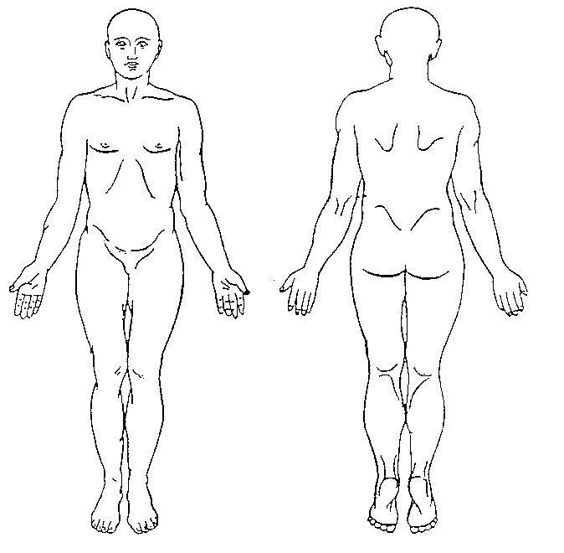

Observation/Description/Size/colour:

Signature: Date:

